EXTERNAL ASSOCIATE
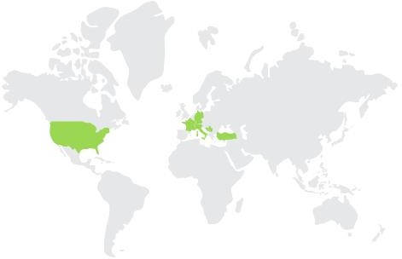 | SERBIA

 | NAME AND SURNAME: | Danijela Milošević
 | AFFILIATION: | Full Professor at University of Kragujevac  Dean of Faculty of Technical Sciences Čačak
 | AREA OF EXPERTISE: | Ontology, intelligent educational systems and electronic learning
 | RESEARCHER ID: (ORCID) | 0000-0001-9612-8807

SHORT BIOGRAPHY
Prof. Dr. Danijela Milošević was born in 1967 in Čačak, where she graduated from elementary school and high school "Filip Filipović" as a Vuk Karadžić diploma holder, majoring in programming in 1986. In the same year, as a scholarship holder of the Technical Overhaul Institute in Čačak, he enrolled at the Military Technical Faculty "Army General Ivan Gošnjak" in Zagreb, majoring in Informatics. She graduated first in her class in 1991 with an average grade of 8.55 and received the title of Bachelor of Information Technology - Software Support.

After graduating, she worked on the design and implementation of the information system of the insurance company "Triglav" in Zagreb. From 1991 to 1994, he worked at the Technical Overhaul Institute as a database designer. Since 1994, he has been working at the Technical Faculty in Čačak. She received her master's degree in 1996 at the Faculty of Electrical Engineering in Belgrade, with prof. Dr. Vladan Devedžić with the topic "Object-oriented knowledge bases of expert systems". Doctoral thesis entitled "Ontological engineering in intelligent tutoring systems" under the mentorship of prof. Dr. Vladan Devedžić was defended on May 22, 2007. at the Faculty of Organizational Sciences in Belgrade.During 1998, she spent 8 months on research studies in the field of Intelligent Tutoring Systems at the University of Athens, Greece. In 2003, she spent 2 months on a study stay at the University of Brighton, England.

Prof. Dr. Danijela Milošević has published over 70 scientific and professional papers and is a co-author of a chapter in the book "New modeling technologies in intelligent educational systems" published by the Springer-Verlah company. He is the author of the monograph "Ontological Modeling in Intelligent Tutoring Systems", the textbook "Computer Science and Informatics" and the co-author of the textbook "Web Application Development Practice" published by the Technical Faculty in Čačak.

Her research areas are ontologies, intelligent educational systems and electronic learning.

